# Steven J. McGee Distributed Systems Architect / Consultant / Patent Applicant

USPTO 13/573,002 Adaptive Procedural Template Coding programmable $$, Economy

Current: Distributed Systems Architect, Patent Applicant – self employed, self directed

June 2004 – March 2018 Simple Always Wins Concepts LLC SAW Concepts LLC (dissolved)

Defense Contractor for Validity Systems, SAIC x 2, MITRE, BAE Systems 1996 – 2002

Master of Science Information Systems Western International University 3.85 GPA 93 - 96

B.A. Psychology, Business Concentration Indiana University of Pennsylvania 1978 - 1992

United States Army Signal Corps Officer 11 years 82 – 93 / ROTC Full Scholarship Recipient

Presenter: International Conference Complex Systems ICCS New England chapter 2006

June 2003 – Present: Patent applicant USPTO 13/573,002: The Heart Beacon Cycle Time – Space Meter Adaptive Procedural Template (checklist of tools, processes, algorithms, protocols… useful to form Distributed Autonomous Groups DAGS synchronized in time – space Checklist: ideas, algorithms, processes, procedures, metrics, meters, signal & telemetry structured data for consistent Eco sustainable economic time cycle epochs for programmable $ / economy / Net, Net of money foundation technology for DeFi, programmable internet, internet of money.

USPTO 13/573,002: Adaptive Procedural Template foundation tech list for net, net of $, economy. System of systems structured data exchange brevity codes - message sets telemetry syntax lexicon mapped to A.I., IoT symbols for human man-machine interface. Foundation technology for programmable $$$ money is being asserted by Banks / tech firms which are forming teams to assert establishment of foundation technology pursuant to securing IP intellectual property patent claims in DeFi / programmable money.

SCOTUS “Alice in Wonderland” ruling "claims may not direct towards abstract ideas".

Figure 2 Improvements as the basis of invention to U.S. Army CECOM Communication Electronics Command's "greatest invention" distributed systems dashboard structured data exchange framework as swords to plowshare use cases for economic reset, climate change sustainable development incentives, stable coin Fed-World Coin.

It is TIME to stand on the shoulders of giants to achieve common synchronized goals.

The Heart Beacon Cycle Time - Space Meter is an Adaptive Procedural Template Framework checklist of ideas, algorithms, processes, procedures, metric, meters, signal & telemetry framework establishing consistent time cycle epochs for the global economy.

Foundation tech is Communications Electronics Command Fort Monmouth's Greatest Invention based on system of systems engineering, structured data exchange. The basis of an invention can be an improvement (s). TITLE: USPTO 13/573,002 The Heart Beacon Cycle Time - Space Meter / Eco sustainable Economic Epoch Heartbeat Patent application type: Adaptive Procedural Template: checklist of tools, processes, procedures, algorithms.. used by a Trade Federation / DAO Distributed Autonomous Organization. Focus is spatial, temporal interoperability, synchronization, stochastic harmonization across time zones. The world currency / economy will be coded how?

USE CASE: System of systems OPSCODE brevity code structured data exchange message sets syntax lexicon telemetry mapped to A.I. symbols. Adaptive Procedural Template foundation tech list for net, net of programmable $$$, IOT...

IF climate change causes a drop in crop commodities by 20–25 % while population grows, THEN this condition will become a matter of national security. THEN this will require revisiting Belgian Economist Bernard Lietaer’s TRC Trade Reference Currency ELSE face chaos by not leveraging proven system of systems & tactics.

FIGURE 3: Foundation tech viewed through the lens of the “Alice in Wonderland” ruling

**Mega banks & FINTECH corporations are forming teams to assert they have established foundation technology for programmable money i.e., Bitcoin, cryptocurrencies, DeFi, FINTECH. Q: What is foundation technology for the net, net of programmable $$$ money - crypto – economy. A: Foundation tech consists:**

**1) Epoch time cycles 2) Syntax used / not during epoch time cycles.**

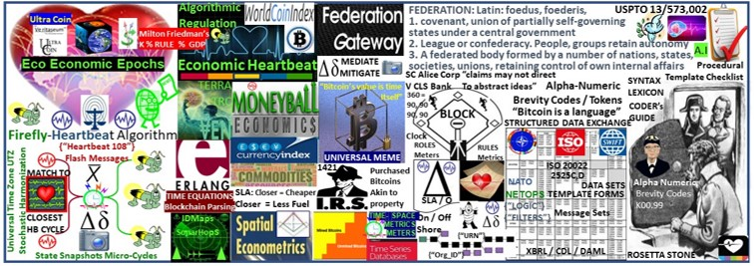

Figure 4 Foundation tech: Checklist of ideas, processes, procedures to achieve common goals

Teams are forming to win the DeFi Distributed Finance / programmable $$$ money IP Intellectual Property wars. The winning team will prove that their IP intellectual property filings established.

Foundation tech described through the lens of SCOTUS 2014 "Alice in Wonderland" ruling? "Claims may not direct towards abstract ideas"

THESIS: All things internet, internet of programmable money are formed using:

1. Time epochs created by oscillating quartz crystal silicon chips

1. Syntax used / not used as programming instructions during epoch time cycles

THESIS SUMMARY: All things internet, net of money blockchains are formed by unicast, multicast, anycast protocols. Programmable money’s improvements are in cryptography. Blockchains are formed by unicast, multicast, anycast and workflow filters. Programmable money’s improvements are in cryptography. Internet 3.0 and the new web will be based on the original structure described by Stanford University. There are no packets, frames, layers, blocks, shards, graphs, hash graphs “bots”, “motes”, … or Satoshi's traversing the net, stored in a blockchain cube. Transactions are unicast, multicast, or anycast (workflow). The afore mention terms are non-existent fabrication.

We need an Eco sustainable Economic Heartbeat with incentives systemically coded into the programmable economy applying consistent time - space metrics, meters and a syntax lexicon library. The German military made a suggestion circa 2003 namely OOTW Operations Other Than War of use of Battlefield Digitization for humanitarian relief, digital dashboards displaying updates to an EIN Earth Intelligence Network drawn from a system of distributed systems.

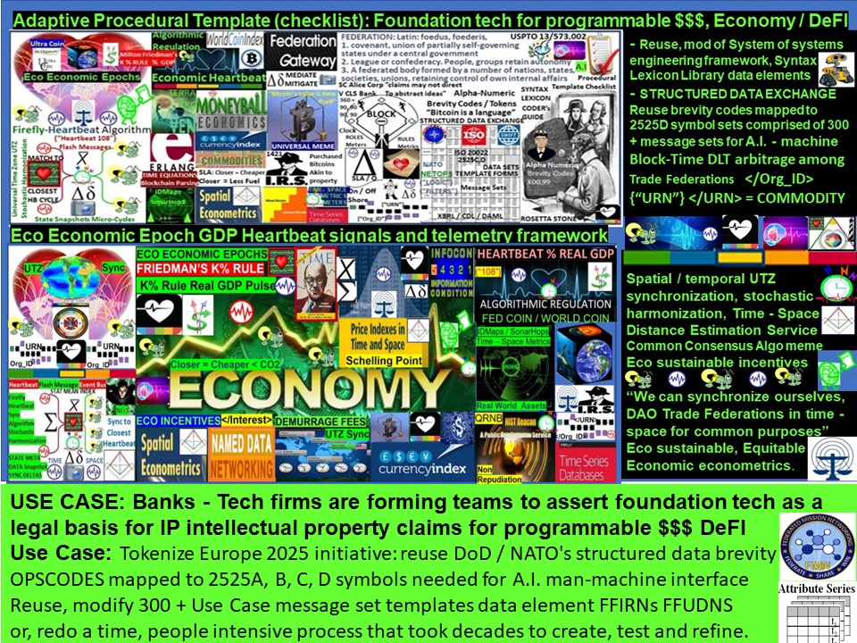Figure 5: Eco Economic Heartbeat / Adaptive Procedural Template (checklist)

USPTO 13/573,002 Checklists (adaptive procedural template in patent application parlance) are visually boring and do not capture attention so this graphic is a picture comprised of symbols and graphics of a checklist of useful tools, procedures, processes, algorithms, ideas that a trade federation would agree to use to achieve, maintain their goals of the trade federation.

USPTO 13/573,002 HEART BEACON CYCLE ADAPTIVE PROCEDURAL TEMPLATE USE CASES:

1. Eco sustainable Economic Heartbeat / Programmable Economy Namespace
2. Distributed Autonomous Organization DAO support. The term DAO was coined by military think tank RAND Corporation circa 2001. Military’s always operate as organizations. NATO operations are usually distributed across many time zones and involve language translations.

1. Common signaling, telemetry, symbol, and data element sets help DAO’s stay synchronized. Joining autonomous trade federations using agile, adhoc [NetOps](https://en.wikipedia.org/wiki/NetOps) is an option to formal merger.

1. Support federations: from Latin: foedus, gen.: foederis, covenant characterized by a union of partially self-governing states or regions under a central (federal) government.

1. Spatial econometrics. Geo-spatial, temporal metrics and meters will be universally consistent and synchronized across time zones. Micro to macro-cycle updates

1. Universal Time Zone UTZ proposal using via improvement to the University of

Bologna / Hungary’s firefly inspired heartbeat synchronization algorithm by matching the firefly synchronization pulse to the closest OPTEMPO Heart Beacon Cycle.

1. The "Grail" A sync'd shared situational awareness view among a system of systems showing statistical mean value indexes can be achieved by reuse of improved net centric warfare methods joined with establishing a universal event bus using fireflyinspired heartbeat synchronization

1. Supreme Court Alice Corp Vs CLS Bank compliant universal memes describe sync delta cyclic changes describes linear sequential, geo-spatial temporal intensity radius hop count econometric metrics and meters where closer is shorter and closer is faster, less fuel, less carbon credits contributing to eco-sustainable goals

1. Algorithmic regulation: firefly inspired heartbeat synchronization algorithm in stocks, currency exchanges is a segue to algorithmic regulation. Improving temporal trade parity between Bitcoin Blockchain & conventional stock exchanges by using the firefly-heartbeat algorithm to take trade speed samples among trade populations across time zones to establish consensus among disparate trade protocols, optimal trade speed / frequency as a statistical mean. Define time intervals with discrete start, stop, TTL Time To Live trade windows using commands embedded within </108> heartbeats, heartbeat messages organic to all systems.

1. Supporting economist Milton Friedman’s K% rule where a “FEDCOIN /

WORLDCOIN currency could be derived from sampling lead economic indicators across a global, universal event bus applying the firefly-heartbeat algorithm tracking changes, updating statistical means

1. Big Data as the “Next Oil”: Establishing a consistent <tag> context library / lexicon and time stamping data by organization <Org_ID> and by data class type and by resource type to form a universal syntax, code, date element, tag Rosetta Stone and reference for coders, programmers.

1. Universal meme metaphor for programmers given all things internet are formed using time cycles / syntax as instructions i.e., universal blockchain meme mediation

**"The economy of imaginary wealth is being inevitably replaced by the economy of real and hard assets'' Vladamir Putin**



Figure 6: The Financial Nostradamus / FutureMan IP Intellectual Property fusion

Veritaseum builds blockchain-based, peer-to-peer capital markets as software on a global scale. “We enable seamless connection of parties and assets without the need for a third or authoritarian interest. Any entity with internet access can participate in these capital markets on a peer-to-peer and one-on-one basis. Veritaseum is a highly disruptive revolution in finance, investment and value. It uses blockchain technology, smart contracts and distributed computing to aid industries and entities suffering from high economic rents, undue friction and gross inefficiencies. thinking of Veritaseum as a vendor of new age (smart) contracts that enable the conditional transfer of value, you can fully grasp both the simplicity and the creatively destructive disintermediation that is Veritaseum. Access to our smart contracts are gained through the purchase of Veritas (VERI), the software token that represents prepaid fees for Veritaseum products and services. Through the possession of VERI, one can access and use our financial machines. Financial machines are multiple, chain-linked smart contracts designed to replicate the functions of entire business divisions of industry, but at near zero margin and without balance sheet exposure, credit risk or counter-party risk.

Economic RESET is a mathematical certainty. Do we RESET the global system of systems as is or do we re-engineer our world using NATO / DOD system of systems engineering framework standing on the shoulders of giants (Edison, Dutch Economist Bernard Lietaer, Friedman) swords to plowshares? See Economist Bernard Lietaer’s TERRA TRC



## Figure 7: Nobel Prize Winning Economist’s K% rule / USPTO 13/573,002

The K-Percent Rule was a proposal by economist Milton Friedman that the central bank should increase the money supply by a constant percentage every year. The K-Percent

Rule was a proposal by economist Milton Friedman that the central bank should increase the money supply by a constant percentage every year. The K-Percent Rule proposes to set the money supply growth at a rate equal to the growth of gross domestic product (GDP) each year. In the United States, this would typically be in the range of 2-4%, based on historical averages. The K-percent rule, proposed by economist and Nobel Prize winner Milton Friedman Milton Friedman Milton Friedman was an American economist who advocated for freemarket capitalism. Friedman's free-market theories influenced economic, is a monetary policy rule that requires central banks to increase the money supply irrespective of the condition of the economy. Supporting economist Milton Friedman’s K% rule where a “FEDCOIN / WORLDCOIN currency could be derived from sampling lead economic indicators across a global, universal event bus applying the firefly-heartbeat algorithm tracking changes, updating a GDP commodity statistical mean index.



**Figure 8: UTZ Universal Time Zone space - time synchronization**

The world’s system of systems needs to be time-space synchronized, stochastically harmonized across the one world, global UTZ Universal Time Zone via heartbeat messages using universally shared, standards based OPSCODE brevity codes drawn from a universal structured data exchange syntax lexicon with over 300 use case templates

e.g., NATO’s lexicon library. NIST’s QRNB intent is to be interoperable with other QRNB’s, therefore, this Max Planck Institute / Announcement is germane to a discussion of a one world government / one world economic system of systems: distributed quantum computers – will need (UTZ Universal Time Zone) stochastic harmonization.

Universal Time Zone UTZ proposal using via improvement to the University of Bologna / Hungary’s firefly inspired heartbeat synchronization algorithm by matching the firefly synchronization pulse to the closest OPTEMPO Heart Beacon Cycle.

Figure 9 Stock Exchange Mediation HFT – Quantum / USPTO 13/573,002

The World Economic Forum WEF at a National Institute of Standards and Technology (NIST) conference 2008: stated the need for a HFT High Frequency Trade circuit breaker.

Given the quantum computing arms race where quantum computer A is "1000 x faster" than B, is it TIME?

Use of the </108> heartbeat message is a method to implement a way to stop trade activities, algorithms belonging to a specific system or company, fund rather than shutting down the entire trading system. Setting time limits (TTL Time To Live) token passing to trade windows pegged to the closest statistical mean heartbeat epoch avoids the potential of rapid attrition of firms with slower quantum, non-quantum systems and the retail individual investor have nots.

If given a choice of detecting </events> {"events"} using quantum particles or waves, are not waves preferable given a wave is more likely to reliably detect an event than a probabilistic based particle? Wave detection doesn't necessarily involve cooling to absolute zero that consumes resources and energy to a greater degree.

HFT Circuit Breaker: </108> Heartbeat message Start, Stop, TTL epoch time limit trade window turn token pass </Org_ID> </URN>

SCOP Heartbeat Administrative interface tool adjusts FIX </108> messages. All systems have "heartbeat" epoch time interval messages. "Heartbeat" = metaphor



## Figure 10: universal meme / metaphor for myriad blockchain algorithm memes

Bitcoin blockchain blocks, agents, motes, bots, heartbeat, beacon are metaphors for intervals, time cycles available to process / not process SYNTAX. The internet is coded, programmed using time cycles to process instructions, commands etc. Given crypto blockchain myriad memes, metaphors "hashgraph" "Ether gas", we are creating new data elements in new syntax lexicons. DoD / NATO's structured data exchange (mapped to symbol sets for A.I - man - machine interface) took decades to achieve consensus -why reinvent the wheel? SOURCE:[**http://en.wikipedia.org/wiki/SIMPLE_(military_communications_protocol)**](http://en.wikipedia.org/wiki/SIMPLE_(military_communications_protocol))



### Figure 11: DeFi / Fintech / Cryptocurrency IP wars Foundation Technology

Banks & Tech firms are forming teams to establish foundation technology for DeFi, programmable money $$$ to establish a legal basis for IP intellectual property patent law claims. Teams may want to reference SCOTUS Alice Corp Vs CLS Bank 2014 "Alice in Wonderland ruling" that states "claims may not direct towards abstract ideas". Physical = opposite of abstract Alice Corporation Vs CLS Bank SCOTUS 2014 Ruling

***Alice Corp. v. CLS Bank International***, 573 U.S. 208 (2014), was a 2014 [United States Supreme Cour](https://en.wikipedia.org/wiki/United_States_Supreme_Court)[t[1]](https://en.wikipedia.org/wiki/Alice_Corp._v._CLS_Bank_International#cite_note-1) decision about [patent eligibility](https://en.wikipedia.org/wiki/Patent_eligibility)[.[2]](https://en.wikipedia.org/wiki/Alice_Corp._v._CLS_Bank_International#cite_note-2) The issue in the case was whether certain patent claims for a computer-implemented, electronic [escrow](https://en.wikipedia.org/wiki/Escrow) service covered [abstract ideas,](https://en.wikipedia.org/wiki/Patentable_subject_matter) which would make the claims ineligible for patent protection. The patents were held to be invalid because the claims were drawn to an abstract idea, and implementing those claims on a computer was not enough to transform that abstract idea into [patentable subject matter.](https://en.wikipedia.org/wiki/Patentable_subject_matter#United_States)

FIGURE 12 SCOTUS Alice Corp Vs CLS Bank “claims may not direct towards abstract ideas”

Bitcoin blockchain blocks, agents, motes, bots, heartbeat, beacon are metaphors for intervals, time cycles available to process / not process SYNTAX. The internet is coded, programmed using time cycles to process instructions, commands etc. It follows that the key to achieving consistency, interoperability among myriad memes and establishing a consistent, systemic one world economic system of systems is to focus on two main common building blocks -- time cycles and syntax. Alice Corp. v. CLS Bank International, 573 U.S. 134 S. Ct. 2347 (2014), United States Supreme Court decision about patentable subject matter (patent eligibility). The patents were held to be invalid because the claims were drawn to an abstract idea and implementing those claims on a computer was not enough to transform that idea into patentable subject matter. In our opinion, physical is the opposite of abstract.

**Alice** **Corp**. **v**. **CLS** **Bank** International, 573 U.S. 208 (2014) compliant ruling “claims may not direct towards abstract ideas”. Physical (baseball meme) is the opposite of abstract

[LINK](https://en.wikipedia.org/wiki/Alice_Corp._v._CLS_Bank_International) WIKIPEDIA: https://en.wikipedia.org/wiki/Alice_Corp._v._CLS_Bank_International



FIGURE 13: FIREFLY HEARTBEAT SYNCHRONIZATION / World Economic Heartbeat

Firefly inspired Heartbeat Synchronization: in a paper entitled Firefly-inspired

Heartbeat Synchronization in Overlay Networks by the University of Bologna Trento Italy along with the University of Szeged, Hungary: “Heartbeat synchronization strives to have nodes in a distributed system generate periodic, local “heartbeat” events approximately at the same time. The heartbeat synchronization protocol for overlay networks is inspired by mathematical models of flash synchronization in certain species of fire flies. Nodes send flash messages to their neighbors when a local heartbeat triggers. Fireflies adjust the phase of their next heartbeat based on incoming flash messages using an algorithm inspired by mathematical models of fire-fly synchronization. Heartbeat synchronization strives to have nodes in a distributed system generate periodic, local “heartbeat” events approximately at the same time. It differs from classical clock synchronization in that nodes are not interested in counting cycles and agreeing on a ID of a current cycle. There is no requirement regarding the length of a cycle with respect to real time as long as a length is bounded, and all nodes agree on it eventually.

**Use Case:** Economic Reset solution: form economic trade federations incentivizing environment friendly business practices leveraging Bitcoin's micro-payment capabilities supporting the TERRA Trade Reference Currency TRC demurrage handling charge. Closer is cheaper, less fuel, < C02 carbon emission in smart contract Service Level Agreements.



**FIGURE 14: TERRA Trade Reference Currency / Crypto micro payment Demurrage fees** Nobel Prize winning Economist Milton Friedman’s K% rule is what I call an “economic heartbeat” K-Percent Rule. DEFINITION of ‘K-Percent Rule’. The K-Percent Rule was a proposal by economist Milton Friedman that the central bank should increase the money supply by a constant percentage every year. The K-Percent Rule proposes to set the money supply growth at a rate equal to the growth of real GDP each year. K-Percent Rule —  Investopedia<http://www.investopedia.com/terms/k/k-percent-rule.asp>

[Economic](https://twitter.com/hashtag/Economic?src=hash) [RESET](https://twitter.com/hashtag/RESET?src=hash) is a mathematical certainty. Do we [RESET](https://twitter.com/hashtag/RESET?src=hash) the global system of systems as is or do we re-engineer our world using NATO / DOD system of systems engineering framework standing on the shoulders of giants (Edison, Lietaer, Friedman) swords to plowshares?

**IF climate change causes a drop in crop commodity by 20–25 % while population grows,**

**THEN this condition will become a matter of national security. THEN this will require revisiting Belgian Economist Bernard Lietaer’s TRC Trade Reference Currency ELSE face chaos by not leveraging proven system of systems & tactics**

Satoshi Nakamoto’s Bitcoin key building block is a time stamp server. **Satoshi Nakamoto: "Bitcoin is intended to be paired with the market place" "the blockchain stores references to market indexes"** Thomas Edison’s Monetary Option:

LINK: <https://www.supermoney.com/2014/06/thomas-edisons-view-money/>

**Demurrage: term used in currency trading to denote cost of currency ownership and/or storage. cost of carrying money… considered superior to interest payments, as it stimulates currency circulation and economic growth. “In a physical sense, demurrage represents a delay that occurs during the transportation of goods via truck. When this happens, the trucking firm delivering the product can opt to pay a flat fee to the receiver to cover any loss incurred as a result of the delay. This fee can be assessed on an hourly basis. Or in the case of gold, demurrage is simply the costs associated with storage of bouillon.** [**LINK https://investopedia.com/terms/d/demurrage.asp**](https://investopedia.com/terms/d/demurrage.asp)

**Figure 15: Nobel Prize Winning Economist Milton Friedman’s K % rule**



**Economist Milton Friedman predicted the rise of a computer capable of automatically adjusting the inflation rate of money. This is precisely what we see in the case of bitcoin, as a regulatory algorithm intelligently adjusts the mining difficulty to make the issuance of blocks more or less easy depending on the demand for network hashing power. No money system we have seen to date can claim it is chronologically regulated. The universal construct of time is the backbone of the cryptocurrency digital economy.**

**Investopedia K % Rule** [Source**:**](https://www.investopedia.com/terms/k/k-percent-rule.asp) **https://investopedia.com/terms/k/k-percent-rule.asp**

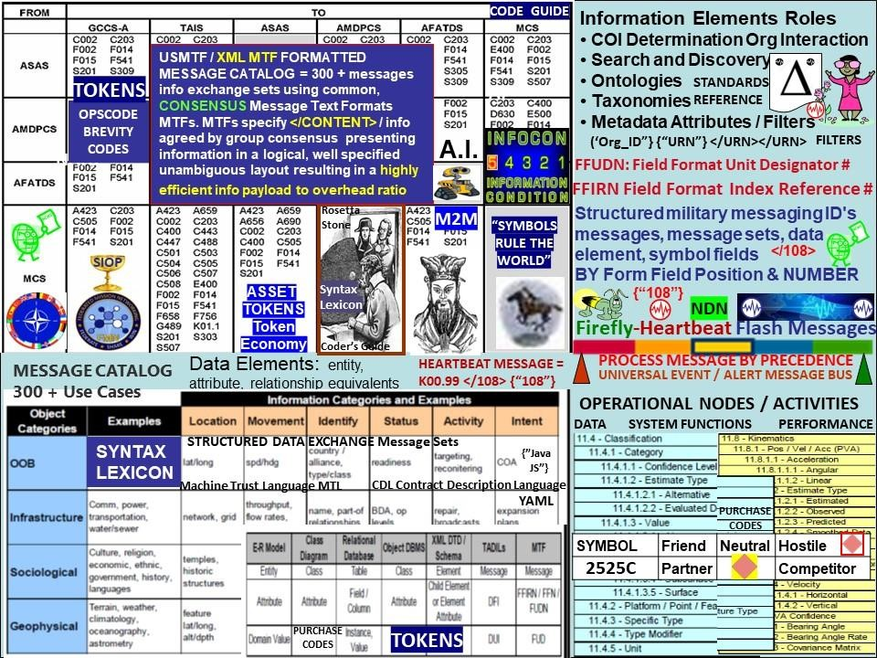

Figure 16: Syntax Lexicon Library Rosetta Stone adapted swords to plowshare from NATO

Common syntax library of various Message Text Formats MTF to enable universal signaling / telemetry among a system of systems is ESSENTIAL. Decades of research at the taxpayer's expense into structured messaging / structured data exchange where the location, type of data identified by table number will help accelerate the process of organizing syntax into categories from disparate systems into data set reference repositories. Many semantic, syntax tags will be reusable. The rules, roles and logic developed by years of research involving of thousands of subject matter experts solving real world issues is the value to be extracted from 300+ message sets. NATO stays synchronized across many languages and cultures so why reinvent the wheel?

MESSAGE CATALOG: The USMTF message library has over 300 messages to choose from to facilitate information exchange requirements. MTFs presenting data in a logical, well specified and unambiguous layout. MTFs are transmission medium neutral. The content of the Message Catalogue has been developed by military operators over the last 20 years. Messages are regularly maintained to keep pace with the latest tactics and doctrine.

**Military brevity codes and stock exchange codes are similar. security Identifier used in financial markets are: SYMBOL, CUSIP, ISIN, SEDOL, RIC Code,** Syntax Lexicon Library



Figure 17: UTZ UNIVERSAL TIME ZONE STOCHASTIC HARMONIZATION / SYNC

We can synchronize ourselves, our cities, towns, cyber-communities in time — space for a common purpose: shared, common, ecologically sound, equitable… econometrics.

UNIVERSAL TIME - SPACE SYNCHRONIZATION: The Heart Beacon Cycle Time - Space

Meter is intended to bridge humanity from our present condition to a higher consciousness described by Extra Terrestrial Groups and organizations like the Law of Time dot org with the Noosphere concept

"One people, one Earth, one Time": "The times we are living in require higher thinking. There has never in the history of the Earth been a time like this. We are now participating in what is called the biosphere-noosphere transition: When life on Earth evolves into an awakened planetary mind (noosphere)". See The Law of Time dot Org

IPFS Interplanetary File System Web3 web page. Specific browsers (Brave / Chrome) & extensions (Brave, Metamask...) are needed to view: #DAO #Web3 #IPFS Web3 <https://ecoeconomicepochs.dao/>

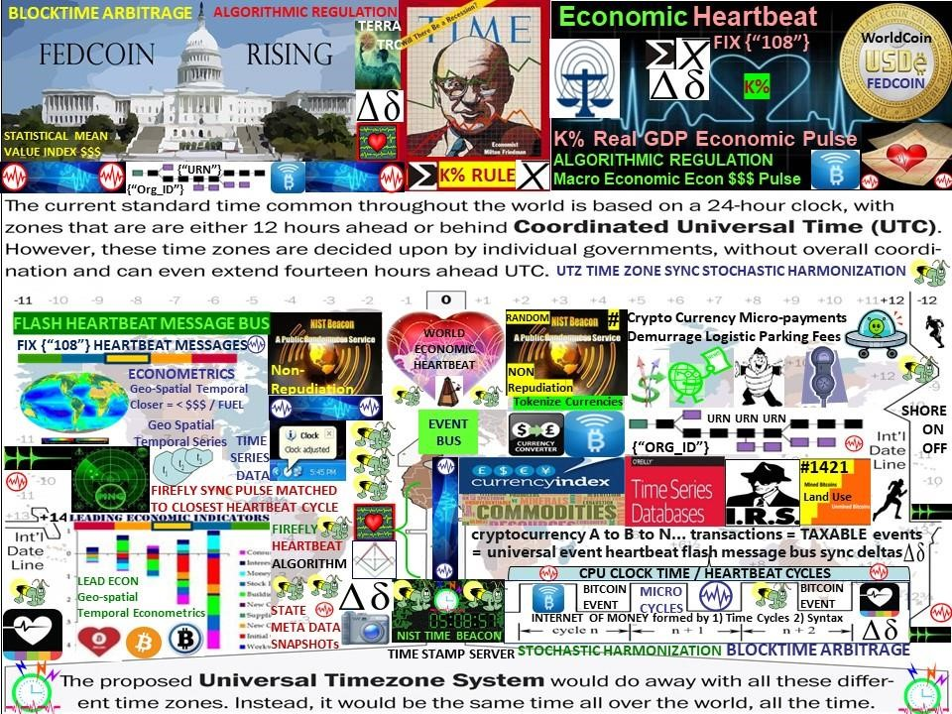

### Figure 18: FEDCOIN / WORLD COIN Synchronization / stochastic harmonization

One world currency for the one world government will require financial events stochastically synchronized, harmonized across the world's time zones and will need to represent a value index of the world's GDP Gross Domestic Product METHOD: Use Thomas Edison's commodity backed index recommendation 1921, Milton Friedman's K % rule, Economist Bernard Lietaer's TERRA TRC Trade Reference Currency concepts in concert with the firefly-heartbeat algorithm developed by the University of Bologna, University of Hungary. Economic Reset solution: form economic trade federations incentivizing environment friendly business practices leveraging Bitcoin's micro-payment capabilities supporting the TERRA Trade Reference Currency TRC demurrage resource handling charge. Closer is cheaper, < fuel, less C02 carbon emissions.

**IPFS Interplanetary File System Web3 web page Web3 page. Brave or Chrome browser with IPFS extensions needed to view.**

# Unstoppable Domains: https://ecoeconomicepochs.dao/

**FIGURE 19: Contact Information**

**Github:** [**http://github.com/Beacon-Heart**](http://github.com/Beacon-Heart)

Telegram: https://t.me/EcoEconomicEpochs

Discord: GDP_Index_Economy#6495

Maven:<http://app.maven.co/profile/SHfEKnA9>

LINKEDIN:<https://www.linkedin.com/in/ecoeconepochs/>

FLOTE: <https://flote.app/user/Heart_Beacon>

Proton Email (secure) ecoeconomicepochs@protonmail.com

PIN INTEREST: https://www.pinterest.com/EcoEconomicEpochs/

WordPress: [http://ecoheartbeat.wordpress.com](http://ecoheartbeat.wordpress.com/)

Substack: https://stevenmcgee.substack.com/

FACEBOOK:<https://www.facebook.com/beaconheart>

MINDS:<https://www.minds.com/beaconheart/>

TWITTER: @Heart_Beacon<https://twitter.com/Heart_Beacon>

Skype: Steven McGee

Unstoppable Domains Domain:<https://ud.me/ecoeconomicepochs.dao> ipfs://bafybeidw7a7a3gbnmzhnuziqaszxnvf2aytyq5bin7gsla7dsihf7t7zyu/ IPFS

**FIGURE 20: It is TIME to stand on the shoulders of giants**

Figure 21: TIME to Federate, Synchronize across UTZ Time Zones for shared goals